Milestone 4: Create onSubmit Cilent Script(Save Validation)
Activity 1: Create Client Script
Description
1.Navigate to Client Scripts:
Go to System UI → Client Scripts in your ServiceNow instance.
2.Click New to create a new Client Script.
3.Fill in the details:
- Name: Prevent save if Assigned To missing – clearly indicates that the script
prevents saving if the field is empty.
- Table: Incident – applies the script only to Incident records.
- Type: onSubmit – executes when the user tries to save the record.
- Active: true – ensures the script is enforced immediately.
4.Paste the script into the script editor section. This script should check if the Assigned To field is empty and prevent the record from saving if it is.

function onSubmit() {
if (g_form.getValue('impact') == '1' &&
g_form.getValue('assigned_to') == '') {

g_form.showErrorBox(
'assigned_to',
'Assigned To is mandatory for High impact incidents.'
);
return false;
}
return true;
}
5.Click Submit to save the Client Script.
6.Verify: Try saving an Incident without filling the Assigned To field. The script should prevent the save and display a warning.
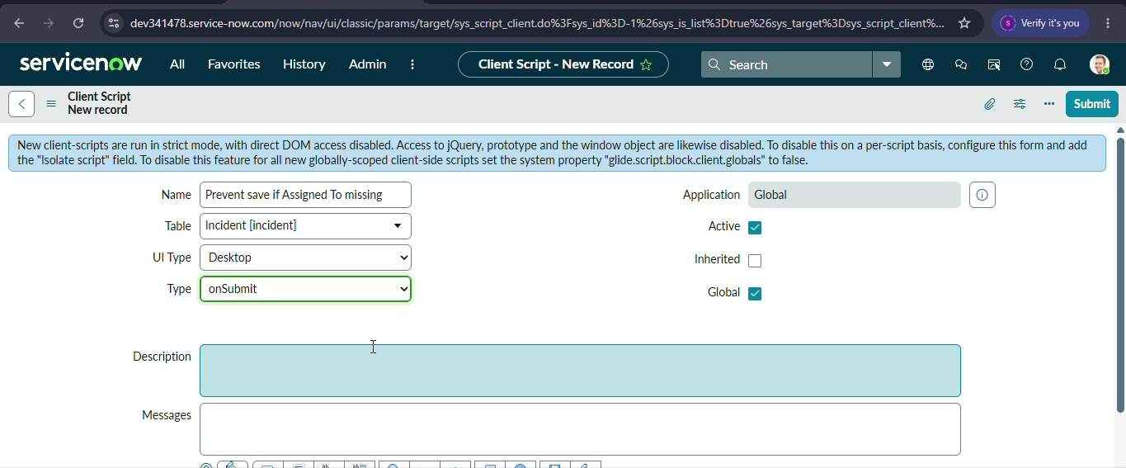

8. Click Submit.

